Assignment 6,Exercise 3:

1. App.java containing the Product and Barcode objects by Spring's dependency injection system, removing the manual object instantiation from App.java.

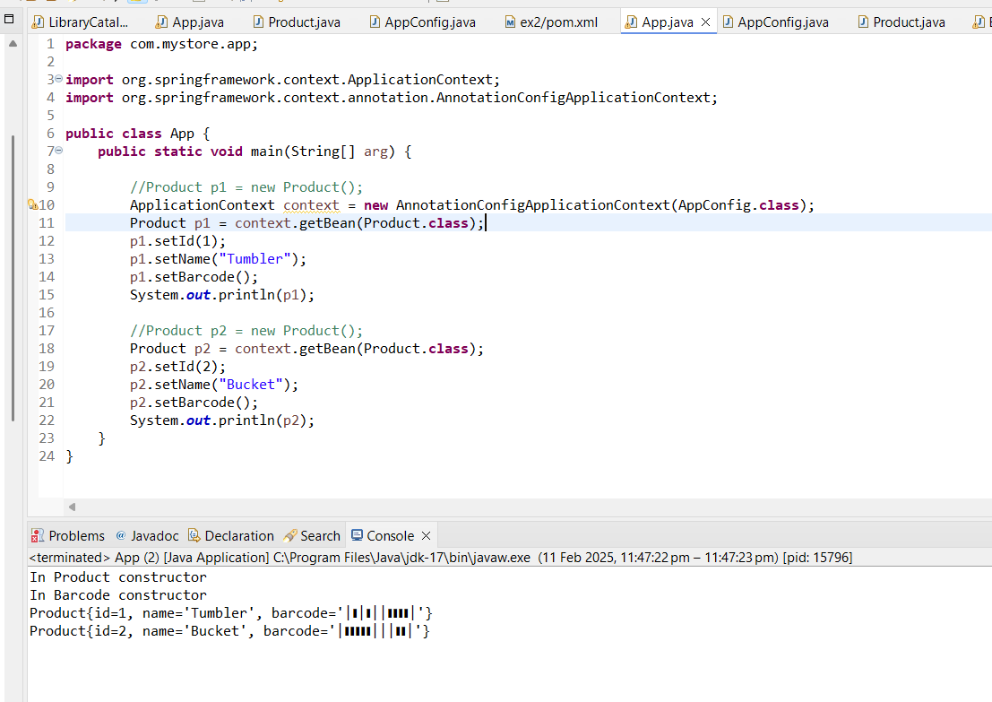

1. AppConfig.Java with @Configuration to create a configuration class and define the Product bean and barcode Bean using @Bean.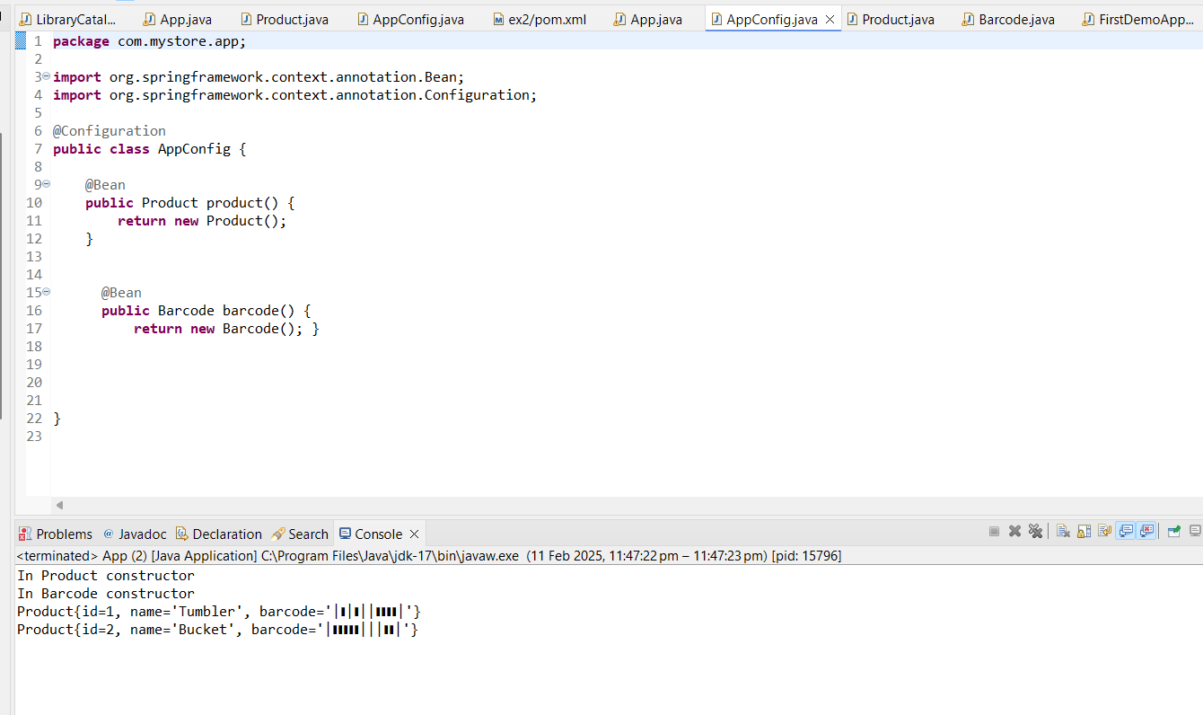
2. Using @Autowired annotation in product class to inject the dependency of Barcode object:

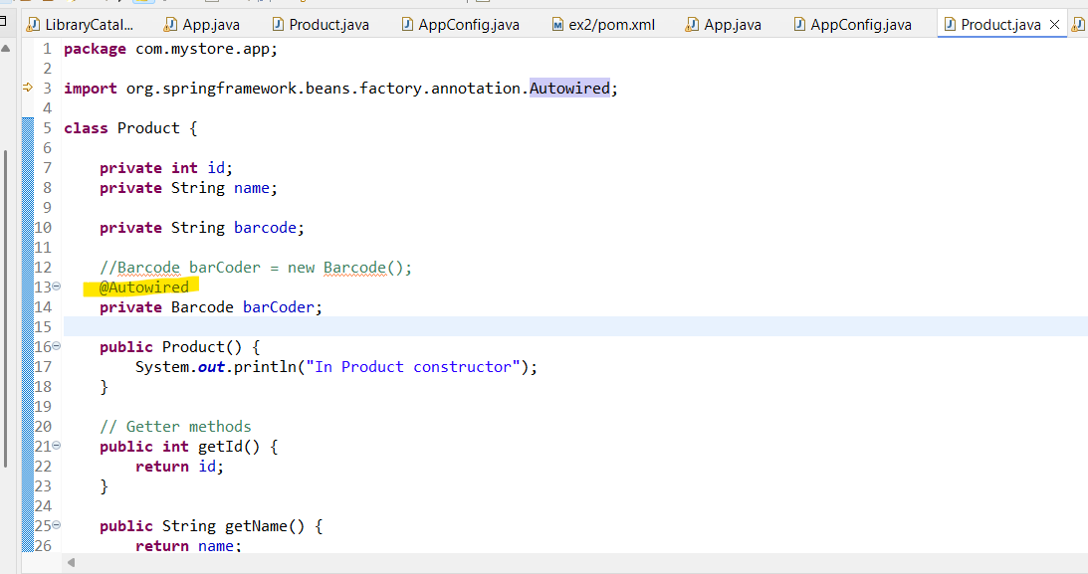

1. Added spring dependencies in Pom.xml :

